This are the all Links related to my project

GitHub Link: GitHub
Live link from Hosting: Render is my Host
Presentation Slide: My Presentation Slide
Video link: YouTube Link
Kuldip Saha Mugdha
IT22018

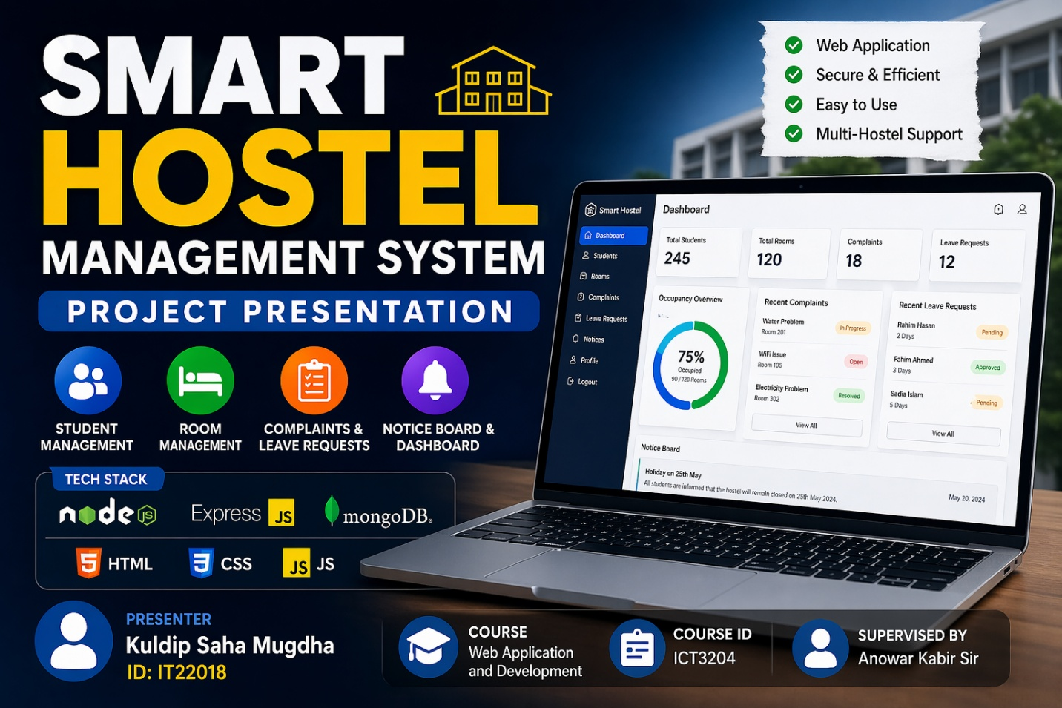

Thank You

